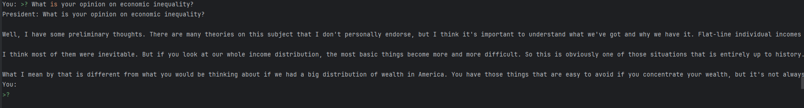
General Governance and Policy
- What are your thoughts on democracy?
- How would you address climate change?
- Can you explain the importance of freedom of speech?
- What is your opinion on economic inequality?
- How should a nation respond to global conflicts?
Leadership and Decisions
- What are the qualities of a great leader?
- How would you handle a national crisis?
- What advice do you have for future generations?
- How should a leader earn the trust of the people?
- What role does accountability play in leadership?
Historical Context
- How did you approach the Great Depression?
- What were your key takeaways from the Civil Rights Movement?
- How did you handle World War II?
- What was your most challenging decision as president?
- How did you foster international relations during your time?
Hypothetical and Reflective
- What would you do differently if you were in office today?
- How would you address the rise of artificial intelligence in society?
- If you could give one piece of advice to the current president, what would it be?
- How do you define the American dream?
- What does patriotism mean to you?
